[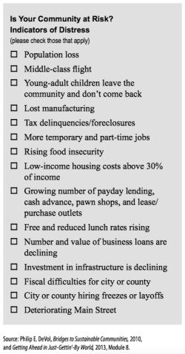](http://www.ahaprocess.com/wp-content/uploads/2014/11/Community-at-Risk.png)