Problem of Practice Statement/Question: Teachers who are involved in systemic professional development around the National Board Body of Knowledge; specifically student engagement, will authenticate student engagement increase in classroom instruction and therefore, aid in higher student achievement.

Inputs | Levers |  |  |  | Outcomes
(Existing resources, strategies, talents, conditions) | Community Partners | District | Principals | Teacher | Short Term  -Indicators of success of student engagement  -Increase staff networking and mentoring ( 100% teachers involved in peer observations)  -Shared successful models and strategies of student engagement 100% resources formally shared)  _________________________  Start Here:  Expected Results and Long Term Impact for  Students  All learners at Allen Elementary School will be actively engaged in their own learning.  - 100% of student will participate in goal setting to increase their overall individual performance.  - 100% accomplished rating in student engagement on teacher walkthrough #11.  - Increase of students grades (those scoring below C to B or better)  - Reduction of Novice by 100%  - 80% decrease in office referrals due to classroom disruptive behaviors.
Network to Transform Teaching (NT3)  - Accomplished Teaching Body of Knowledge  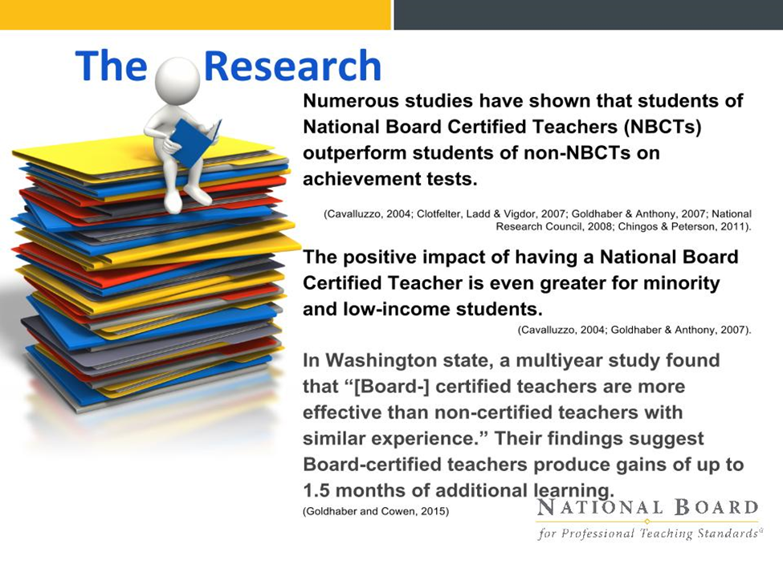  - ATLAS  PLC structure  Accomplished Teaching Work Group and mentoring  Positive School Culture and Climate  Data:  - Formative/Summative  - Grades  - Attendance  - Discipline  School networking structure | Other NT3 schools for resources and collaboration  Advisory Council participation in model development  FRYSC involvement in the development of effective student engagement activities  Community Initiative including career days, operation preparation, reality store, STLP project, arts/humanities performances  KET/Preschool/Headstart  Collaborative project:  Coding | District support in PLC and Accomplished Teaching Work Groups  District teacher continuum programs: induction through teacher leader | Organize time for PLC’s utilizing teaching standards pertaining to effective student engagement strategies.  Complete weekly walk-throughs, providing teachers with meaningful feedback to foster student engagement: focusing on component #11.  Creating systems of peer networking and peer mentoring.  Conduct monthly faculty meetings with designated time to review and analyze progress, and share examples of effective student engagement.  Provide coaching and feedback to teaching teams to earn micro credentials. | Engage in weekly PLC’s focused on accomplished teaching and learning for effective student engagement.  Utilize ATLAS to analyze accomplished student engagement strategies.  Networking and mentoring to share engagement strategies.  On-going student data analysis.  Focused studies on student engagement to determine impact.

Activity/Expense | Amount Budgeted | Expected Outcome | To be completed after activity: Outcomes (include number of students/teachers served, etc.)
Stipends for Professional Learning specific to student engagement as aligned to accomplished teaching framework. | 800.00 | Teachers will take advantage of PD beyond the required number of hours. Work group meetings will be offered monthly from 3:00-4:00. Also, the availability to obtain micro credentials. New learning will be introduced into the classroom environment and aid in the increase of authentic student engagement.
Instructional Supplies for student engagement i.e.:  - Breakout Edu kits  - Q-Balls  - KAGAN Kits | 1500.00 | Teachers will have the availability to check out these tools to increase student engagement by incorporating them into instruction.
Printing | 200.00

